A Tableau Analytics Study of Global COVID-19 Trends (January–July 2020)

Introduction
The main purpose of this analysis project is to leverage tableau’s data visualization filtering attributes to analyze the COVID-19 pandemic progression in the first 7 month, January 2020 to July 2020. Through building an interactive dashboard which displays four different visualizations; the study goal is to establish which months experienced the deadliest COVI-19 surges, the countries that felt the greatest burden of confirmed cases, deaths distributions across world regions as defined by WHO, and the nations that experienced the steepest in active infections in the first 7 months.
The analysis project is meant to transform a large epidemiological dataset into a comprehensive, actionable intelligent visual interaction that could be useful for public health decision making, resource allocation, and future pandemic preparedness. Generally, this project highlights the real- life value of business intelligent analytics tools, especially tableau’s filter-based dashboards in transforming complex fast-moving datasets from any domain into useful insights.
Data Description
The select dataset for this study is the COVID-19 Dataset published on Kaggle by contributor Jillanisofttech. This dataset covers the period from January 22, 2020 to July 22, 2020, which are the initial seven months of global health pandemic (COVID-19). This dataset consists of 35,157 rows of daily country-level data organized across six key columns which are Recovered, Active, New Cases, New Deaths, New Recovered, and WHO Region, highlighting significant view of the pandemic’s progression across all the inhabited regions of the world.
The publicly available dataset COVID 19 Dataset, was obtained from Kaggle, the leading data science platform which provides free peer-reviewed datasets for research, academic, and analytical purposes.

Analysis and Methodology
The analytical tool Tableau Desktop, was selected as the primary analytical engine for this project because it has the industry leading data visualization capabilities, intuitive drag-and-drop interface, and its powerful filtering features that helps users to slice and explore big datasets without the use of code. The analysis dashboard consists of four important visual interactions with important insights, the stacked bubble plot for the three peak moths of COVID-19 deaths, the country map showing high cases, horizontal bar plot of deaths recorded on July 22, 2020 and trendline of active infections for top 5 countries over the 7 months period.

Analysis Results
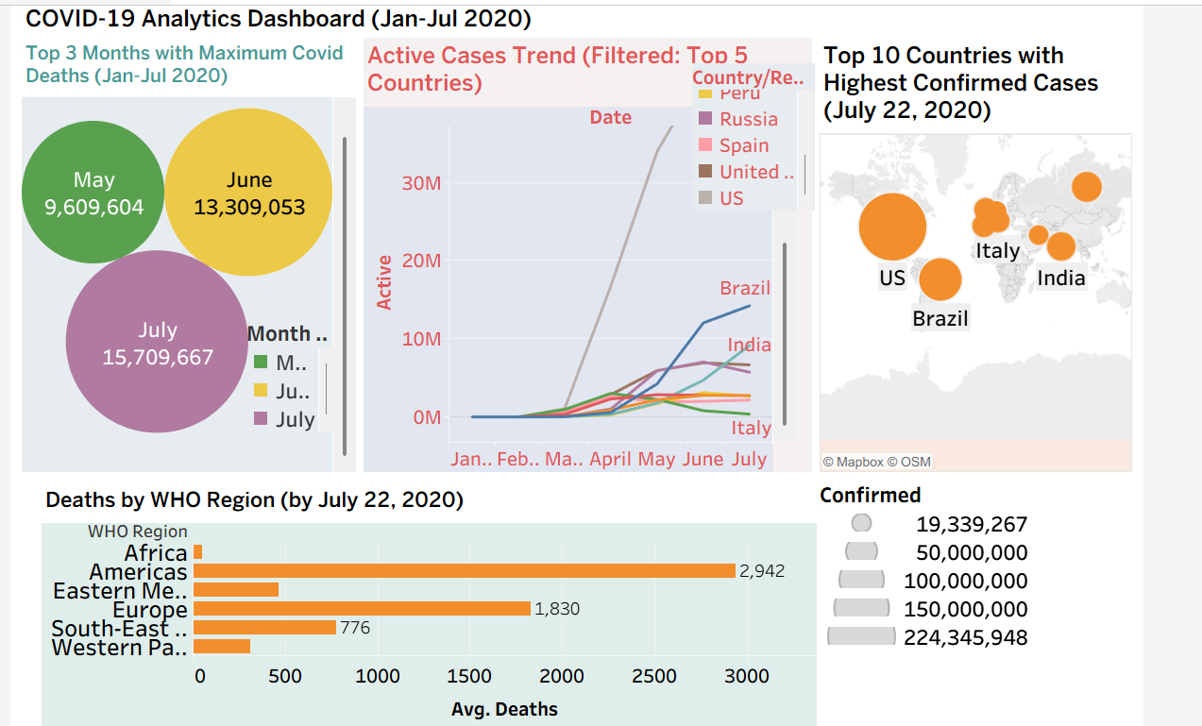
Dashboard – COVID-19 Analytics Dashboard (Jan–Jul 2020)
Insights1: July 2020 was the pandemic’s deadliest month of the study period as highlighted in the bubble plot of the three months with the highest deaths.
Insight 2: The USA, Brazil, and Russia emerged as the top countries heavily infected by mid July 2020 as shown by the map of the top 10 most infected countries
The America WHO region had the highest cumulative deaths as shown in the bar chart
The USA maintained the highest active cases counted every month across the period. The line chart titled 'Active Cases Trend (Filtered: Top 5 Countries)' uses a Tableau country filter to isolate the five nations with the largest active caseloads and plots their daily trajectories from January through July 2020.
Africa’s extremely low recorded death count compared to other regions can be misleading and may cause dangerous data reliability problem.

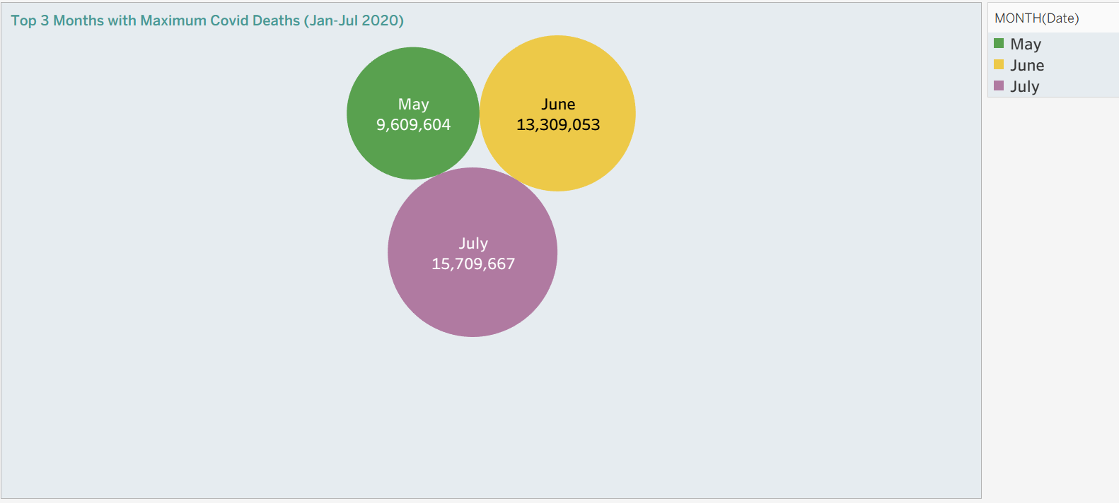
This visualization highlights three months between January and July 2020 that recorded the highest Covid-19 deaths globally. July tops the list followed by June and May.
Top 10 Countries with Highest Confirmed Cases (July 22, 2020)
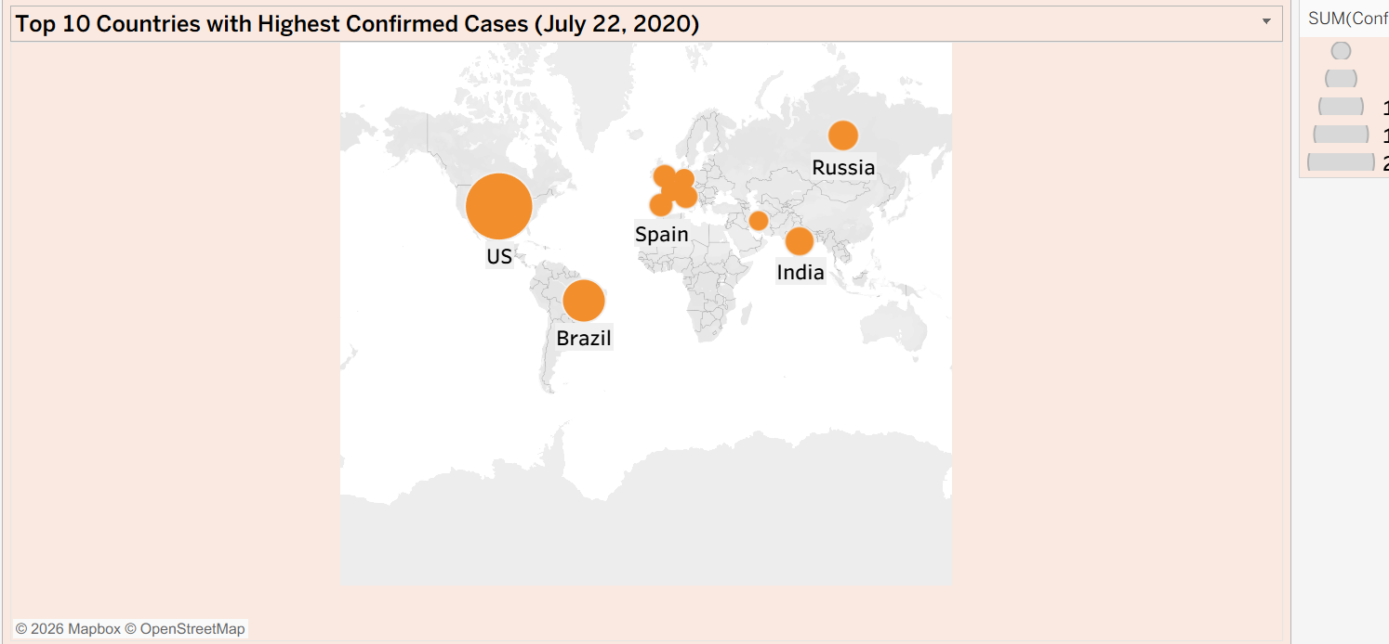
The map shows top countries with highest confirmed deaths on July 22 2022. The USA, Brazil and Russia were the 3 top countries.
Deaths by WHO Region (Filtered: July 22, 2020)
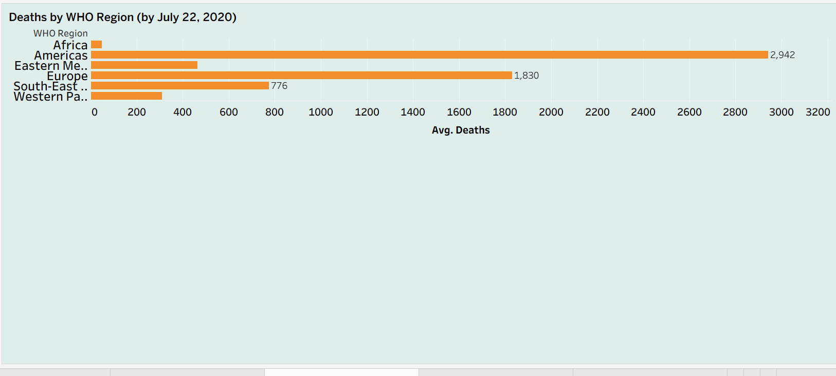
Regional total deaths on July 22, 2020 shown with America with the highest followed by Europe. Africa recorded the least
Active Cases Trend (Filtered: Top 5 Countries)

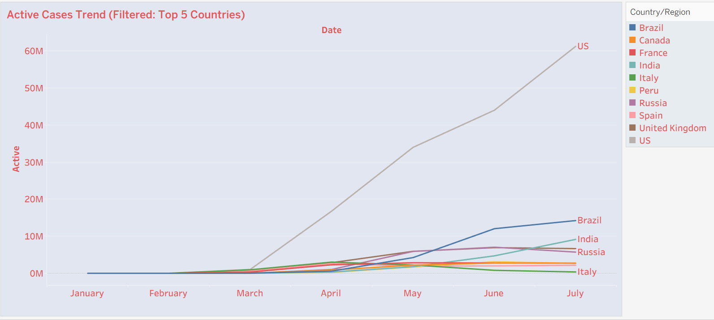
Active cases of Covid-19 trendline shows the USA with the most cases throughout the period

Conclusion
This analytic study project successfully applied Tableau’s powerful filtering and dashboarding features to the COVID-19 real world global dataset. The process yielded a significant set of insights across temporal, geographic, regional and country-level pandemic attributes. The analysis highlights May through July 2020 as the deadliest of the study period, with July having the highest. The geographic regional analysis uncovers America was global pandemic epicenter above Europe and Asia. The USA, Brazil and Russia accounted for the most numbers of both deaths and confirmed deaths. Africa recorded low reported deaths might be due to limitations of testing infrastructure rather than low mortality, this gap could have serious consequences for international aid allocation and decision-making policies.
Overall, this analysis project demonstrates how data visualization tools like Tableau can make sense and transforming data into completeness, testing equity, and real-time monitoring infrastructure in managing global health crisis

